August 22nd, 2010
Hi
Well, as you undoubtedly know, there was a general election in Australia yesterday. And the result is too close to call, with the two major parties having a similar number of votes. It will take a few days to sort out the final vote count and what kind of coalition is formed with the minority groups. Two themes that were in the voters. minds, and also in mine. One is the “political execution” (as it has been called) by the present PM Julia Guillard of her former leader and PM Kevin Rudd. Another is the “mines tax” which Rudd had proposed to raise to 40%, but which Guillard will reduce to 30% and Tony Abbot (the opposition leader) would leave at the present rate. I, along, with virtually every economist in the world, agree with the the tax level proposed by Rudd, the reason being that the ores in the ground belong to the country and not any particular company. The mining companies do not create the wealth, as other businesses have to do; all they do is just dig the ores out of the ground for free (apart from the cost of machinery, etc.). So, the argument goes, it is the country that should profit from what is their assets rather than the companies. There was a big turnout of Australian voters in HK who voted at the Australian Consulate. While voting in Australia itself is compulsory, this is not the case for Australians living overseas. I guess this is sensible as where would an Australian living in the middle of nowhere, such as Boston (electorally speaking only!) go to vote?
Earlier this week I was having a lot of trouble falling asleep. So I decided to do something I have not done in a while and which is supposed to help, which is to drink some milk. It seemed to work.
In Hong Kong, the first combined heart and lung transplant was carried out yesterday at Queen Mary Hospital (on HK Island). The operation was on a 27-year old female and lasted 17 hours. She had a hereditary disease called familial amyloidotic polyneuropathy (FAP). At the same time, her kidney was transplanted to another person. If you want more on it, go to the SCMP article at:
http://www.scmp.com/portal/site/SCMP/menuitem.2af62ecb329d3d7733492d9253a0a0a0/?vgnextoid=6d32ded33559a210VgnVCM100000360a0a0aRCRD&ss=Hong+Kong&s=News
Talking about the SCMP, sales of the newspaper have increased substantially recently here and also overseas as people are able to download it onto their iPads (and, for a while, is free).
The other day, while going down in the lift, I saw a T-shirt with the sign: “Singapore - a fine city”!! I agreed with this as the city is very clean and green. However, when I looked at the rest of the T-shirt, I realised I had misinterpreted the meaning. There is another meaning. Can you guess what it is? Try, then check your guess by referring to the picture of a T-shirt at the end of the letter (which is similar though not identical to the one I saw). The picture is upside-down, which is deliberate to make it a little more difficult for you to cheat!
I bought a new swim suit the other day. My current one is falling to bits and is at the stage where it might actually drop off!
My new passport arrived the other day - by international courier mail, which I did not request, as there is an additional charge for this! Exactly the same thing happened in 2005 when it was renewed then. However, this time, the person I e-mailed said that for people overseas, courier is not an option, even though the application form is unchanged and actually gives you a box to tick/leave unticked for use of courier service. So I am having a bit of a battle with them at the moment, pointing out that in 2005, the department admitted that it was wrong and refunded the courier fee to me. As I still have the e-mails and letters from 2005, I mentioned that, if necessary, I will send them. We will see what happens. The new passport differs in that there is now a thick plastic page which has lots of data stored on it. You should renew your NZ passports as it is useful to have more than one travel document.
I went to the dermatology clinic the other morning. Not really necessary except to just tell them the result of the hospital biopsy. So, the next appointment set for December.
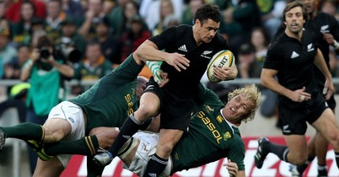
Yesterday, the ABs beat SA 27-22 in front of 94,000 spectators in Johannesburg, to take the Tri-Nations title. However, they left the win till late. With only three minutes remaining, they were behind 17-22, but then scored two tries in the remaining minutes. In the UK at the moment, the Women’s Rugby World Cup is under way. I was unaware of this until I saw a bit of the NZ-SA game on our local TV news!! The NZ women won easily by 55-3 and will probably easily win the cup, which I think they have won every time.
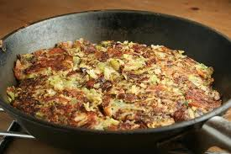
Have you heard of a food dish called 'bubble and squeak'? It is a traditional British dish and is popular in NZ and probably also in Australia. It consists of a mixture of left over potato and vegetables heated in a pan. It is very nice. You may have had it at Nana's place. Anyway, I have started making it here though often it is with left-over rice rather than potato (as I usually cook enough rice for several days rather than just enough for one meal).
That’s about it for this week.
Cheers

